Bahria University,

Karachi Campus



LAB EXPERIMENT NO.

_______

LIST OF TASKS

|  |  |
| --- | --- |
| TASK NO | OBJECTIVE |
| O1 | Fibonacci series ( 0,1,1,2,3,5,8…) for and while loop |
| 02 | Repeatedly print the value of the variable xValue, decreasing it by 0.5 each time, as long as xValue remains positive. (while loop) |
| 03 | Print the square roots of the first 25 odd positive integers. (while loop) |
|  |  |
|  |  |
|  |  |
|  |  |
|  |  |
|  |  |
|  |  |
|  |  |
|  |  |
|  |  |
|  |  |
|  |  |

Submitted On:

____________

(Date: DD/MM/YY)

1. **Fibonacci series ( 0,1,1,2,3,5,8…) for and while loop**

**SOLUTION:** {

int a = 0, b = 1, c, d=2, limit;

Console.Write("enter limit: ");

limit = int.Parse(Console.ReadLine());

Console.WriteLine("----------------------------------------\n");

Console.Write("{0} {1} ",a,b);

while (d<limit)

{

c = a + b;

a = b;

b = c;

Console.Write(c+" ");

d++;

}

}

**OUTPUT:**

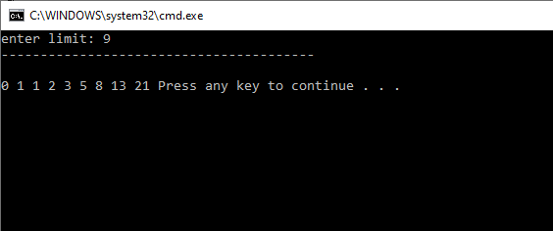

1. **Repeatedly print the value of the variable xValue, decreasing it by 0.5 each time, as long as xValue remains positive. (while loop)**

**SOLUTION:**

{

double i = 6;

while (i>=0)

{

Console.WriteLine(i);

i-=0.5;

}

}

**OUTPUT:**

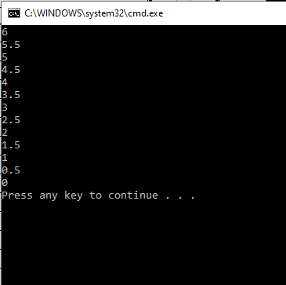

1. **Print the square roots of the first 25 odd positive integers. (while loop)**

**SOLUTION:**

{

int i = 1;

while (i<=51)

{

double x = Math.Sqrt(i);

Console.WriteLine("square root of {0} is {1}",i,x);

i += 2;

}

}

**OUTPUT:**

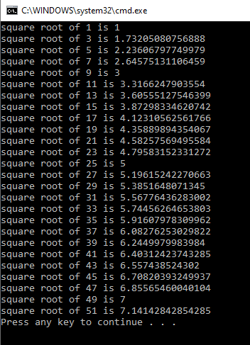

**\*\*\*\*\*\*\*\*\*\*\* LAB EXAMPLES\*\*\*\*\*\*\*\*\*\*\*\***

**SOLUTION:**

Console.Write("enter number one: ");

int num1 = int.Parse(Console.ReadLine());

Console.Write("enter number two: ");

int num2 = int.Parse(Console.ReadLine());

Console.WriteLine("select any option: ");

Console.WriteLine("a)----> add");

Console.WriteLine("b)----> sub");

Console.WriteLine("c)----> mul");

Console.WriteLine("d)----> exit ");

while (true)

{

Console.Write("\nchoose from above: ");

char resp = char.Parse(Console.ReadLine());

if (resp == 'a')

{

Console.WriteLine("{0}+{1}= {2} ", num1, num2, num1 + num2);

}

else if (resp == 'b')

{

Console.WriteLine("{0}-{1}= {2} ", num1, num2, num1 - num2);

}

else if (resp == 'c')

{

Console.WriteLine("{0}*{1}= {2} ", num1, num2, num1 * num2);

}

else if (resp == 'd')

{

Console.WriteLine("program terminated");

break;

}

else

{

Console.WriteLine("wrong selection");

}

}

**OUTPUT:**

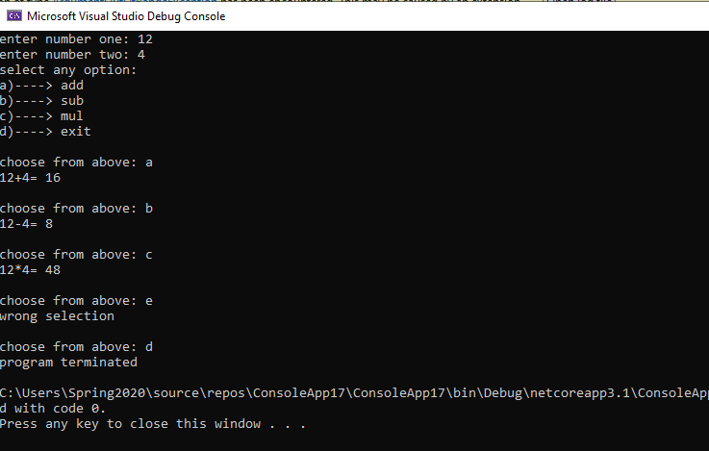

**\*\*\*\*\*\*\*\*\*\*\* FACTORIAL \*\*\*\*\*\*\*\*\*\*\*\***

**SOLUTION:**

int num;

int factorial = 1;

Console.Write("ENTER NO OF FACTORIAL: ");

num = int.Parse(Console.ReadLine());

while (num>0)

{

factorial *= num;

num--;

}

Console.WriteLine("factorial = {0}",factorial);

**OUTPUT:**

